**Чепоков Елизар ПИ-18-2**

**НИС №2 “Практическая работа с базой данных временных рядов InfluxDB”**

--11----------------------------------------------------------------

insert cluster,well=ID0678,temperature=27,region=Perm pressure=6.8

insert cluster,well=ID0678,temperature=27,region=Perm pressure=6.8

insert cluster,well=ID0678,temperature=27,region=Perm pressure=6.8

insert cluster,well=ID0100,region=Perm pressure1=0.64,pressure2=1.15

insert cluster,well=ID0678,temperature=27,region=Perm pressure=6.8

insert cluster,well=ID0101,region=Osa pressure1=0.68,pressure2=2.75,pressure3=16

insert cluster,well=ID0101,region=Osa pressure1=0.87,pressure2=3.5,pressure3=67

insert cluster,well=ID0102,region=Barda pressure1=0.12,pressure2=1.5,pressure3=1.7

insert cluster,well=ID0102,region=Barda pressure1=0.15,pressure2=1.55,pressure3=1.75

insert cluster,well=ID0102,region=Barda pressure1=0.45,pressure2=1.75,pressure3=1.65

insert cluster,well=ID0102,region=Barda pressure1=0.35,pressure2=1.95,pressure3=1.85

insert cluster,well=ID0102,region=Barda pressure1=0.35,pressure2=1.95

insert cluster,well=ID0103,region=Ufa pressure1=1.35,pressure2=2.95,pressure3=5

insert cluster,well=ID0103,region=Ufa pressure1=2.35,pressure2=3.95,pressure3=5.5

insert cluster,well=ID0103,region=Ufa pressure1=3.35,pressure2=1.95,pressure3=4.5

insert cluster,well=ID0103,region=Ufa pressure1=2.35,pressure2=4.95,pressure3=7.5

insert cluster,well=ID0103,region=Ufa pressure1=2.35,pressure2=4.95

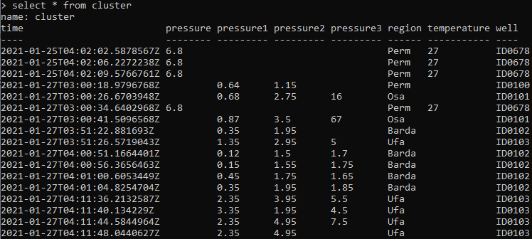

--------------------------------------------------------------------

--12----------------------------------------------------------------

select pressure1 from cluster where time<now()-3d17h30m

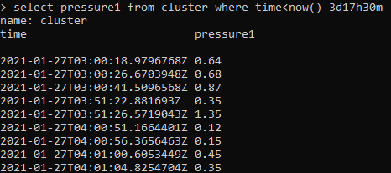

select pressure1 from cluster where time<now()-3d17h40m

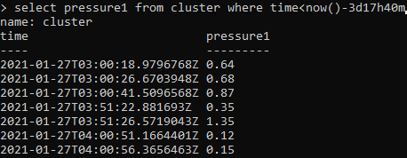

select pressure1 from cluster where time<now()-3d18h

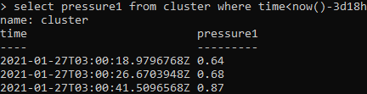

--------------------------------------------------------------------

--13----------------------------------------------------------------

select pressure1 from cluster group by region

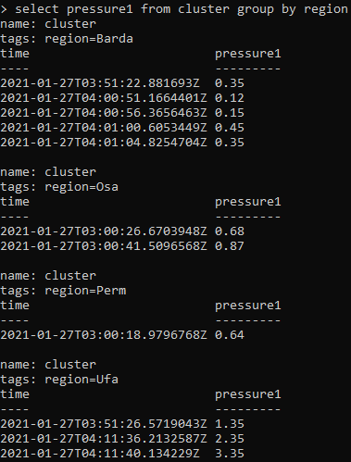

--------------------------------------------------------------------

--14----------------------------------------------------------------

select mean(pressure1) from cluster where time>now()-5d group by time(1d)

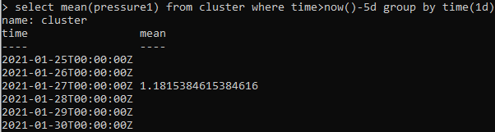

--------------------------------------------------------------------

--15----------------------------------------------------------------

select pressure1 from cluster fill(previous)

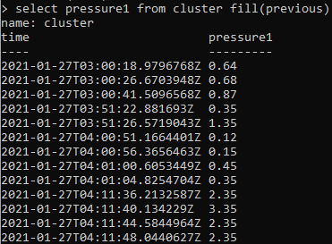

select pressure1 from cluster fill(none)



select mean(preassure2) from cluster group by time(1h) fill(linear)



--------------------------------------------------------------------

--Homework--------------------------------------------------------------

--1)-Вывести-максимальные-за-час-значения-для-всех-давлений-куста2------

-----для-текущего-месяца------------------------------------------------

select max(/pressure/) from cluster where time>now()-30d group by time(1h) fill(none)

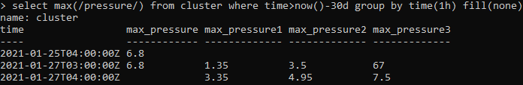

------------------------------------------------------------------------

--2)-Вывести-средние-на-интервалах-в-6-часов-значения-давлений1-и-2,----

-----превышающих-1.54,-куста2-для-разных-регионов-для-текущего-месяца---

select mean(pressure1), mean(pressure2) from cluster where pressure1>1.54 and pressure2>1.54 and time>now()-30d group by time(6h), region fill(none)

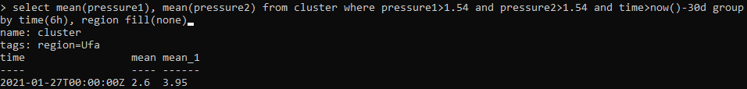

------------------------------------------------------------------------

--3)-Добавить-несколько-записей-для-куста,-чтобы-данные-по--------------

-----давлению1-отсутствовали--------------------------------------------

insert cluster,well=ID0104,region=Ekaterinburg pressure2=1.15,pressure3=0.9

insert cluster,well=ID0104,region=Ekaterinburg pressure2=0.14,pressure3=0.12

insert cluster,well=ID0104,region=Ekaterinburg pressure2=1.35,pressure3=0.28

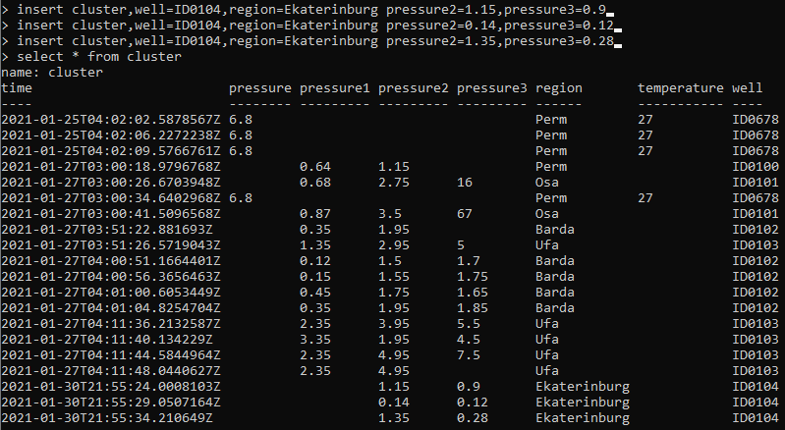

------------------------------------------------------------------------

--4)-Вывести-значения-давлений1-и-2-с-использованием-автозаполнения-----

-----разными-способами--------------------------------------------------

select pressure1, pressure2 from cluster fill(previous)

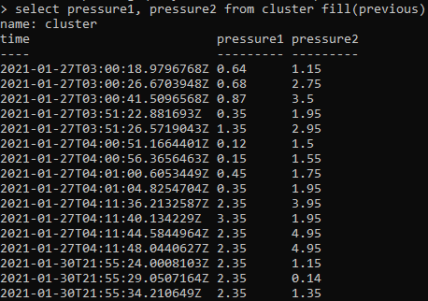

select pressure1, pressure2 from cluster fill(1)

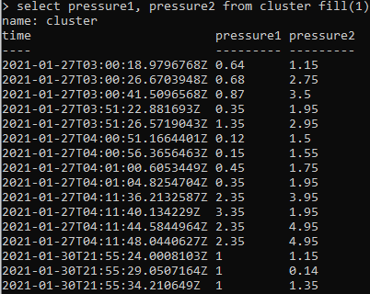

select pressure1, pressure2 from cluster fill(null)



